

Football Penalty Shooter

Project Report for CS352

**Presented by**

Kunal Gupta (150001015)   
Bhor Verma (150001005)

Computer Science and Engineering

3rd Year

*Under the Guidance of*

Dr. Somnath Dey

Department of Computer Science and Engineering

Indian Institute of Technology Indore

Spring 2018

## Contents

Contents 2

Introduction 3

Modules 3

The Physics 3

The Shooter 4

The Defender 4

Camera Angles 5

Texture and Fonts 5

Technicalities 5

Classes and structures 5

Functions 7

Playing the Game 9

Building, Running and Updating 9

Playing 10

## Introduction

The project is a Football Penalty Shooter Game. The game is similar to that of the Football Penalties in real life. The player is able to interact with the game in several ways. Namely the player can:

* Move around the camera with the mouse/touchpad to get a better field of view.
* Zoom in/out using the keyboard, again to get a better field of view.
* Set the angle of the shot, and thus point it in the desired direction.
* Set the power of the shot, that is, the speed of the ball.
* View the goal statistics and switch from one mode to the other using the keyboard.

The goal is defended by a moving Defender, which moves in direction of the shot. He will deflect the ball on contact. Points are awarded whether the shot is a goal.

## Modules

### The Physics

This will consist of the physics and the trajectory tracer when the ball is shot.

It applies gravity effects, frictional effects as well as controls the bouncing of the ball. It also looks after the collisions of the ball with the defender as well as the poles of the Goal Post, which uses oblique collisions, similar to:

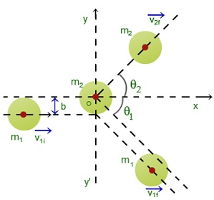

The related calculations are done in the code and are omitted here for simplicity.

### The Shooter

This will consist of the shooting power and angle which the player can set. The angles can be adjusted to a range of -60° to 60° horizontally and from 0° to 50° vertically.

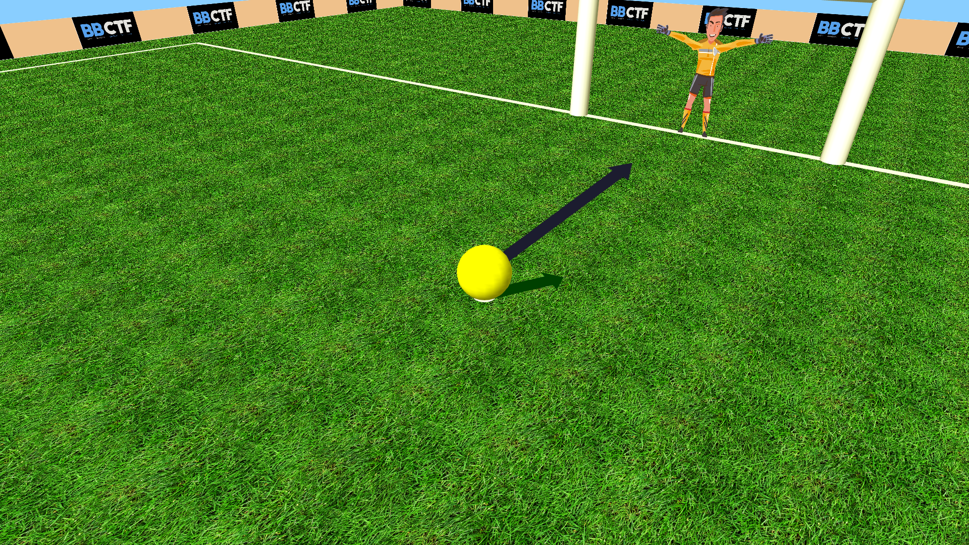

### The Defender

Similar to a real-life goalkeeper, it moves to defend the shot. The hands of the defender move continuously, whereas the whole defender moves in the direction of the shot to defend it.

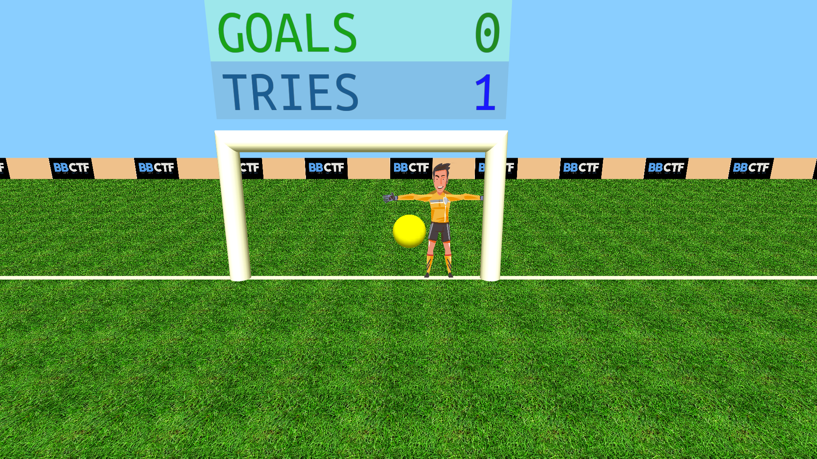

### Camera Angles

The player can change the camera angles for the penalty using the mouse so as to view the shot in different angles.

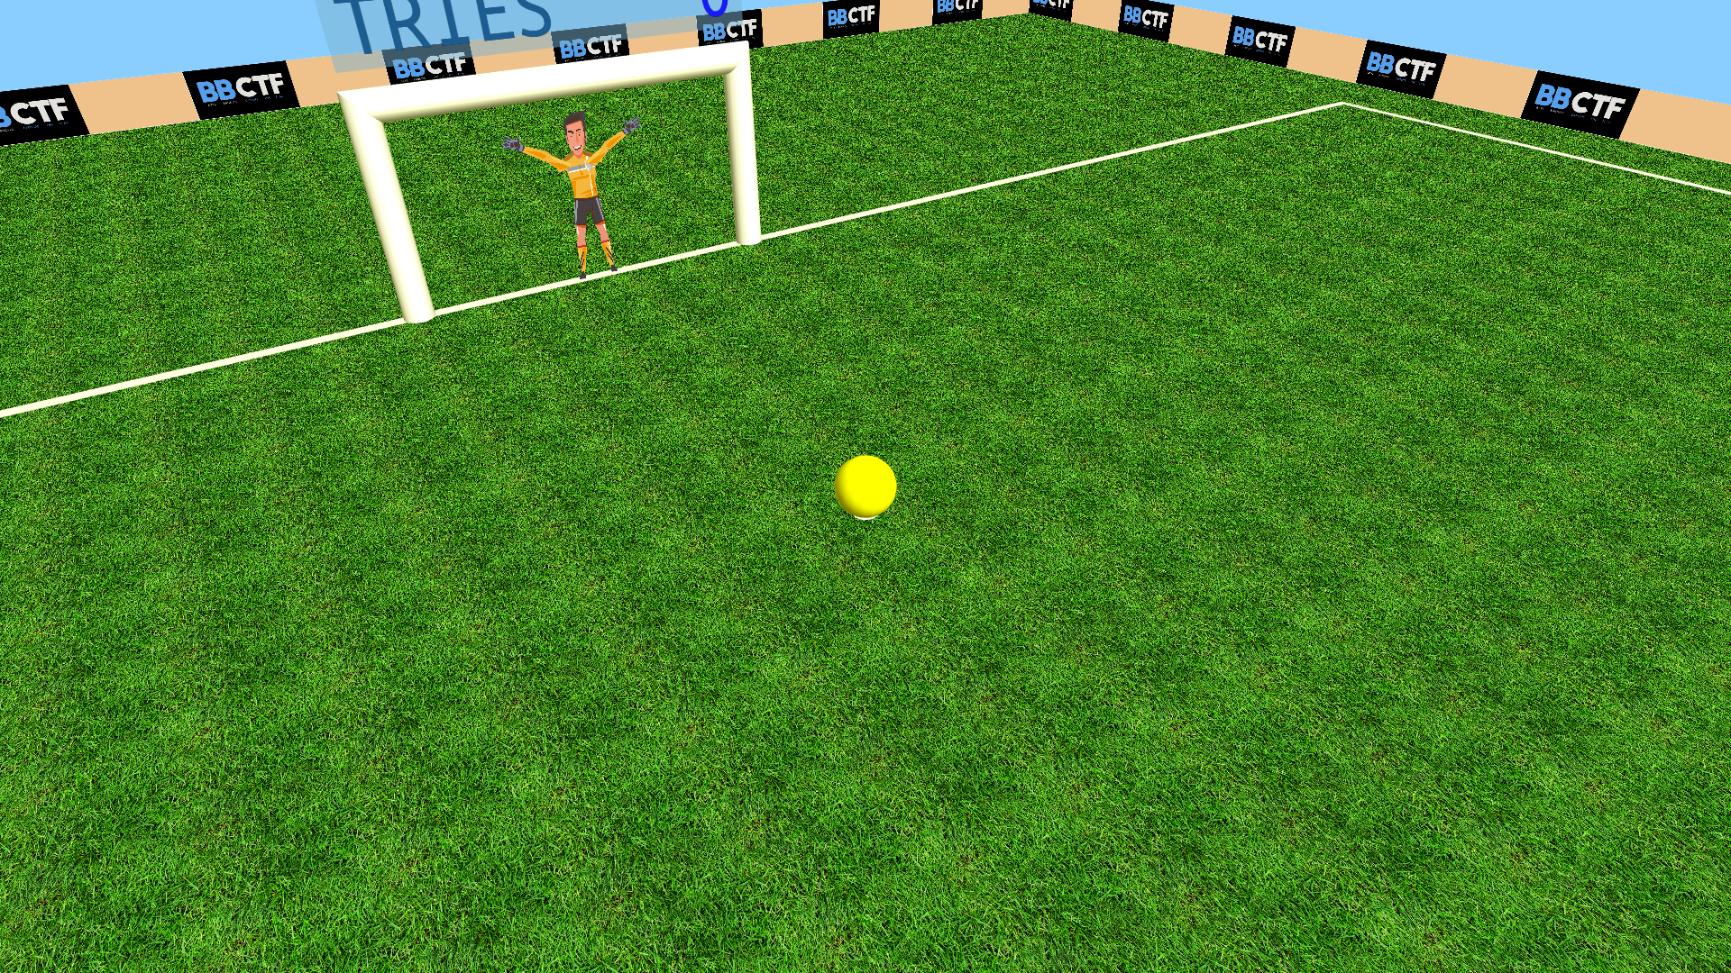 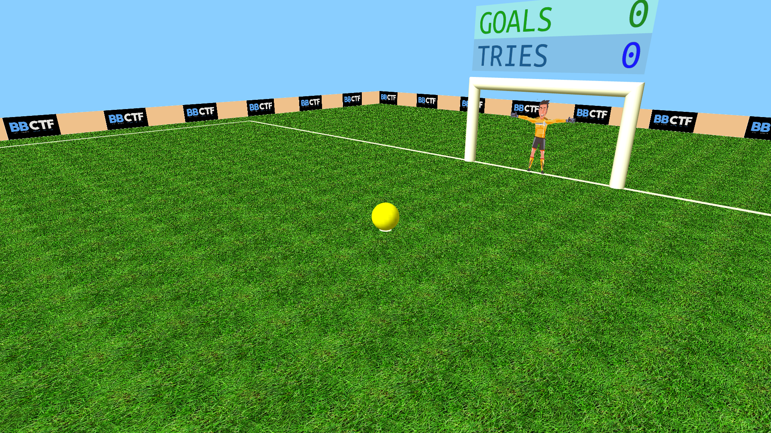

### Texture and Fonts

These contain the required functionalities for loading textures with transparency.

Further we have created a custom font system, which uses transparent textures to use them as font, which can be used in 3D and can be resized, unlike the Raster Fonts, and also have a good width and thus can be easily seen, unlike the Stroke Fonts.

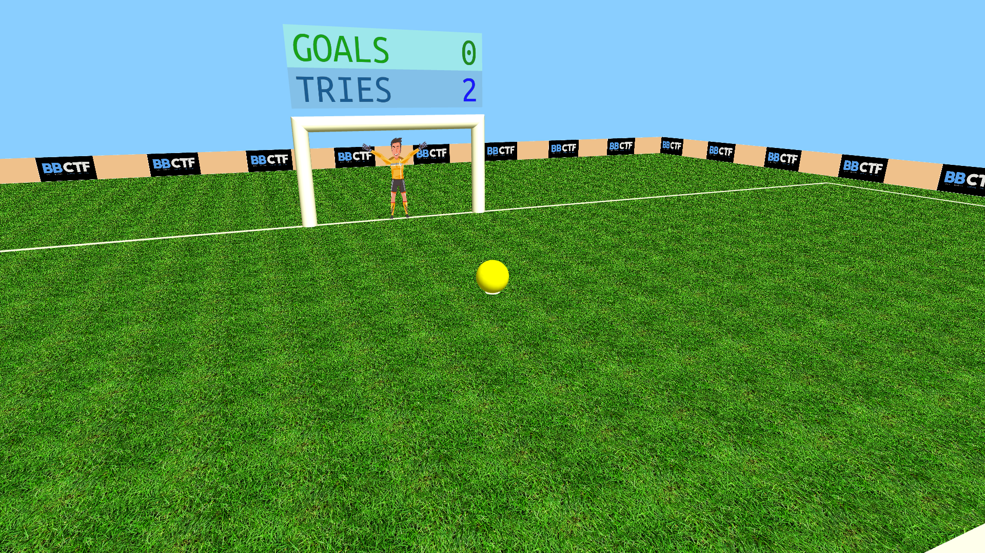 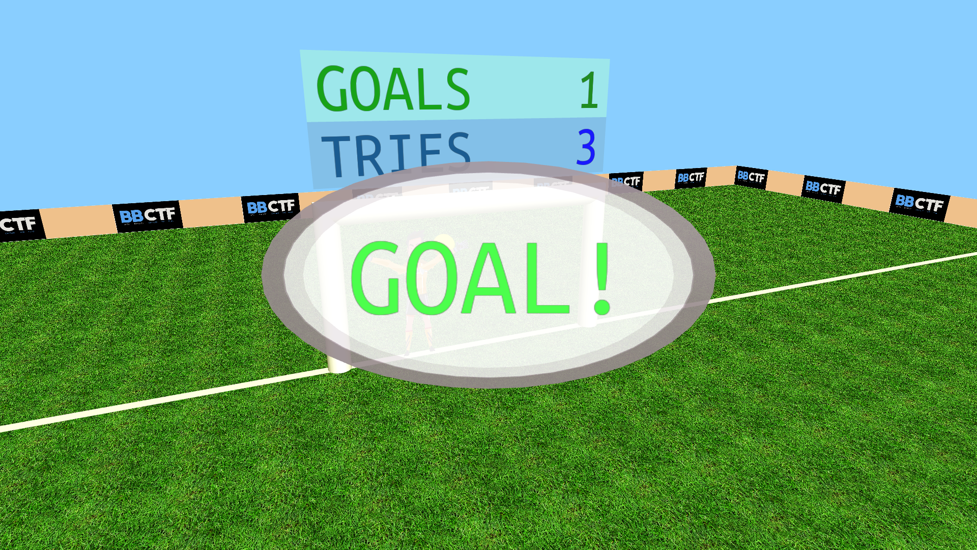

## Technicalities

### Classes and structures

The classes and structures used in our project broadly have the following relation:

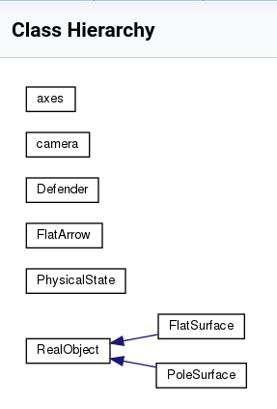

**Axes**

A helper class for modularity of values of quantities along the 3D axes.

**Camera**

A class that contains information about the camera: Horizontal and Vertical Angles and distance from the point to be seen.

**Defender**

Contains the physics of the defender as well the drawing methods.

**FlatArrow**

The arrow used for setting the shot angle – contains the angles and drawing methods.

**Physical State**

The helper class that contains the physical state – velocity, acceleration and position – of any object, like the defender and the ball.

**Real Object**

Used for drawing the FlatSurface (ground) and PoleSurface (poles of the PoleSurface).

### Functions

**functionalities.cpp/.h**

* **void** handleResize(**int** w, **int** h)  
  Handles the window resize using the given width ‘w’ and height ‘h’.
* **double** distanceBW(axes axes1, axes axes2)   
  Calculates Euclidean distance of between the given positions in 3D space.
* **bool** isItGoal(PhysicalState ball)   
  Calculates whether the given shot is a goal, by inspecting the ball and goal coordinates.
* **void** backgroundMusicPlayer(**int** _)   
  Plays the background music on a loop using the system() function and the paplay utility in linux.
* **void** initialiseEverything()  
  Contains all the methods to be called and the values to be set/reset when the game is started or ball is reset. Is called using the initialiseEverythingCallback() function.
* **void** initialiseEverythingCallback(**int** _)   
  A callback function to be used in conjuction with glutTimerFunc() to be called every time the screen needs to be reset, for the next or the first shot.
* **void** drawGoalPost()  
  Draws the Goal Post.
* **void** cameraPosition(axes point, **double** distance, **double** zAngle, **double** xAngle)   
  Is actually a wrapper for gluLookAt() for easier camera manipulation using a point, two angles and the distance from the point.
* **void** rainBox(**double** alpha = 0.7)   
  Is used for drawing the colored power meter scale for adjusting the shot power in SHOOTING mode.
* **void** drawPowerMeter()  
  Calls the rainBox() function and draws the arrow corresponding to the power level.
* **void** drawHUD()  
  Function responsible for drawing the Heads Up Display or the HUD. It shows the initial Instructions to the game and the power meter.
* **void** updateDefenderPosition(**int** _)   
  Uses the physics responsible to change the position/velocity of the defender stored in the PhysicalState class.
* **int** convertToTexture(**const** **char** *filename)   
  Load the file with the given filename. The file must contain integers to pixel values for each location in the texture. To generate such a file use textureloader.py along with a RGBA PNG file. This loaded file is written into a new file with binary data so that it can be loaded faster into an array to be used as a texture.
* GLuint loadTextureFile(**const** **char** *filename)   
  Loads the file created by convertToTexture() and creates an OpenGL RGBA texture using it. The returned value is the Texture integer.
* **void** drawChalkLines()  
  Draws the white lines on the ground marking the outsides.
* GLuint convertAndLoadTexture(**const** **char** *filename)   
  A wrapper function for calling convertToTexture() and loadTextureFile().
* **void** start2DTexture(GLuint texture, **bool** lightingDisabled)   
  Contains the initializations to be done before after after loading the texture. It basically makes the texture ready for use.
* **void** end2DTexture(**bool** lightingDisabled)   
  Contains the clean up to be done after drawing with the texture has finished.
* **float** writeMultiLineText(string text, **int** texture, alignment align)   
  Repeatedly calls writeText() for every line of text provided in the given string.
* **float** writeText(string text, **int** texture, alignment align)   
  This is the function created for using textures as fonts. Given a font texture file (can be created using fontloader.py and a TrueType font) it crops out each character from the texture and draws it on a transparent quadrilateral and repeats the same for each character, giving it the effect of using another font. Thus we implemented our functionality of loading TrueType fonts.
* **void** rotateMsg(**int** _)   
  A simple callback function used to rotate the ‘GOAL!’ or ‘MISS!’ message for a 3D animation, drawn using the showMsg() function.
* **void** showMsg()  
  Is used for drawing the ‘GOAL!’ or ‘MISS!’ message.

**main.cpp**

* **void** showScore()  
  Shows the number of scored goals along with the total shots above the Goal Post.
* **void** updatePos(PhysicalState &p, **double** t)   
  Calculates the Trajectory of the ball, using the friction, bouncing effects and collision and updates the PhysicalState of the ball accordingly.
* **void** updatePosCallBack(**int** _)   
  A call back to update the PhysicalState of the ball when SHOOTING mode is set.
* **void** draw()  
  The function that is passed in glutDisplayFunc(). It calls all the modular drawing function in a sequential manner so as to draw the game canvas.
* **void** incrementPowerMeter(**int** _)   
  Increments the power when the SPACE BAR is held down.
* **void** idle()  
  The function passed to glutIdleFunc() for perform background processing tasks or continuous animation when window system events are not being received.
* **void** handleUpKeypress(**unsigned** **char** key, **int** x, **int** y)   
  Handling key releases on the keyboard. Changes the state of the respective key in downKeys[].
* **void** handleSpecialKeypress(**int** key, **int** x, **int** y)   
  Handling key presses of special keys on the keyboard – namely the up, left, right, down arrow keys, to be used in setting the shot angle.
* **void** handlePassiveMouse(**int** x, **int** y)   
  Handles the mouse pointer movement for adjusting the camera angle for the current view and angle of the game.
* **void** myInit(**void**)   
  Contains initializations such as enabling lighting, depth, blending, anti-aliasing, etc.

**shapes.cpp**

This file contains the implemented functions like draw() of the classes previously describes.

## Playing the Game

### Building, Running and Updating

The game can be built from sources using the following commands:

* git clone https://github.com/iamKunal/OpenGL-3D-Football-Penalty-Shooter.git #Latest on GitHub
* **cd** OpenGL-3D-Football-Penalty-Shooter
* mkdir build && **cd** build
* cmake **..**/
* make

The game can be run by running the following the build directory previously created.

* make run

To update the game simply run the following from the root directory of the game.

* git pull

### Playing

Playing the game is simple as the game also provides the instructions for playing:

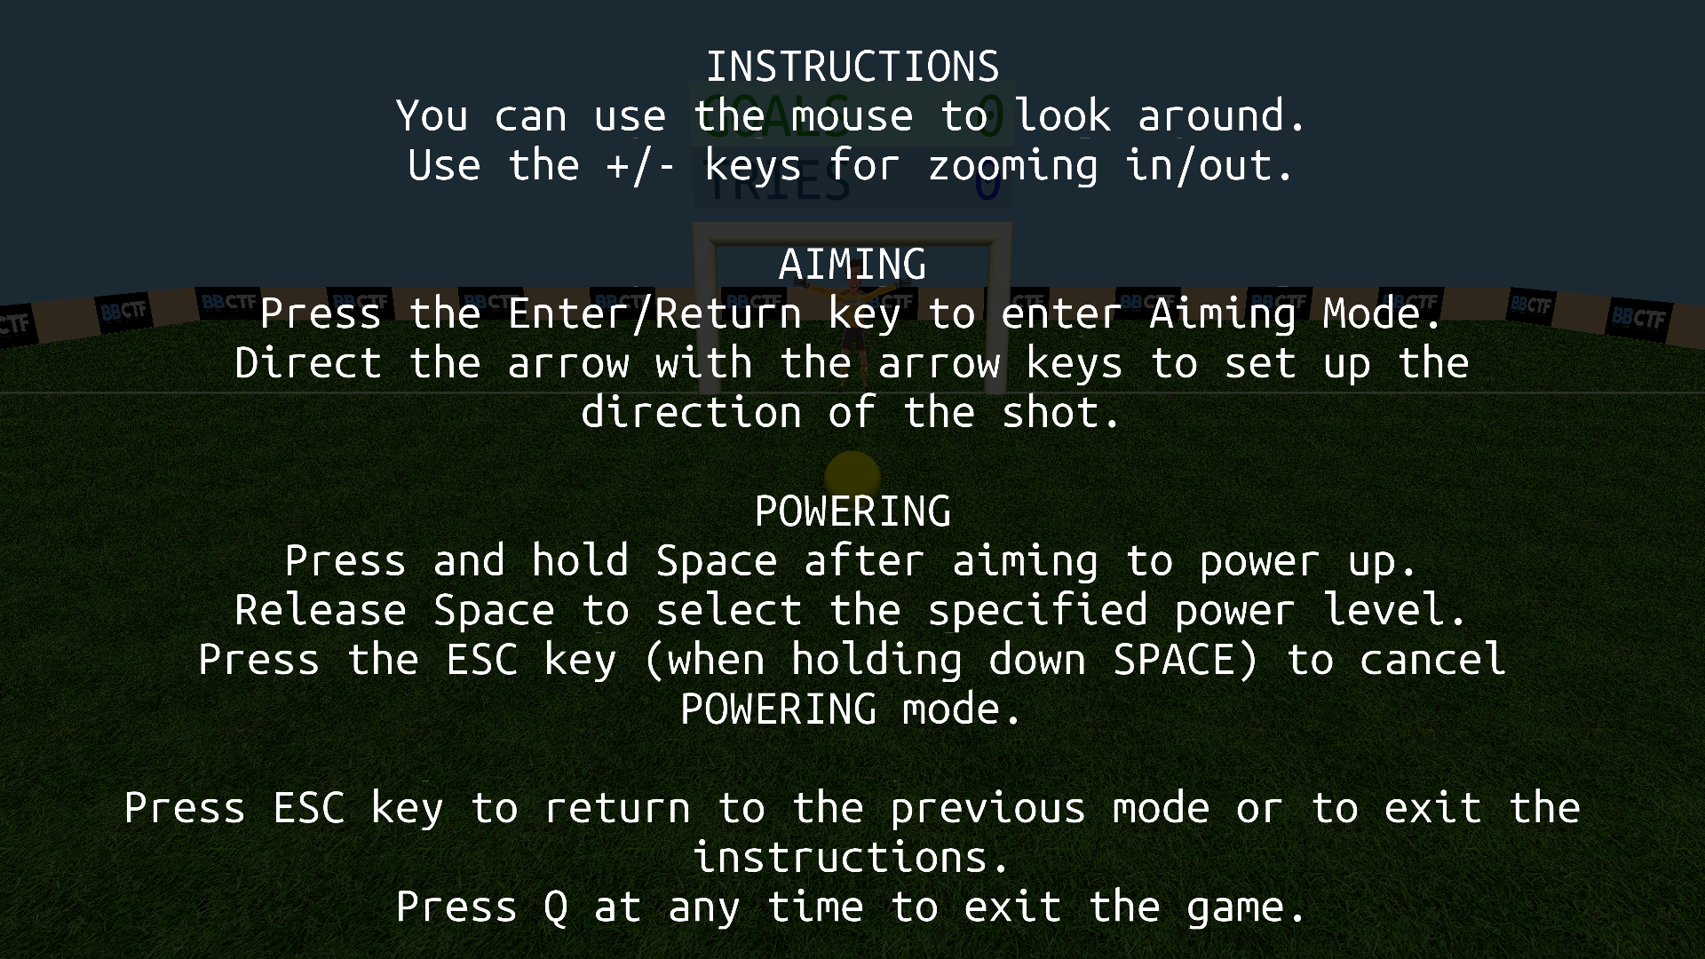

This mode is also called the HELP mode internally.

**Adjusting Mode**

The initial screen after quitting the instructions is internally called ADJUSTING mode and is used for just looking around in the game with the mouse.

**Aiming Mode**

The player can change the angle of the shot (same as the angle of the blue arrow) using the arrow keys on the keyboard.



**Powering Mode**

Herein, the player can press and hold the spacebar for the desired power which can be seen using the arrow on the power meter and then release it at the desired power level.

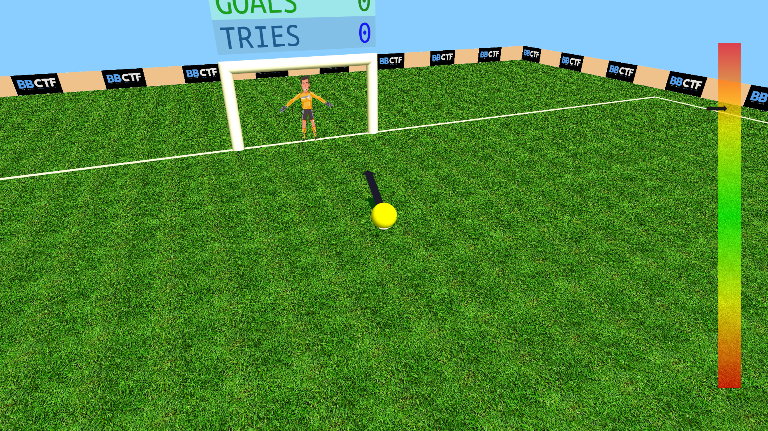

**Shooting Mode**

Internal to the game, the shooting mode is the actual mode where we can see the shot in action.

